Syeda Reeha Quasar

14114802719

6C7

Aim

Install and configure NetAnim.

Experiment - 9

Computer Networks Lab

# **EXPERIMENT – 9**

## **Aim:**

Install and configure NetAnim.

## **Theory:**

NetAnim is an offline network animator tool that now ships along with the ns-allinone-3.xx package.

It can animate the ns-3 network simulation using an XML trace file that is generated as an output during simulation.

So, the necessary steps for creating this XML trace file and setting its related attributes should be done in the ns-3 simulation code itself.

For a beginner who starts learning ns2, the animation that is created by NetAnim will be a more attractive factor in learning and understanding a simulation. Undoubtfully, each and every beginner of ns-3 will be very happy while seeing the first animator output of their simulation on NetAnim for the very first time. So let us enjoy seeing our first network animation on NetAnim.

## **Installation:**

NetAnim is an offline animator based on the Qt toolkit. It currently animates the simulation using an XML trace file collected during the simulation.

NetAnim dependencies while installing NS3, install the dependencies given below:

$] apt-get install mercurial

$] apt-get install qttools5-dev-tools

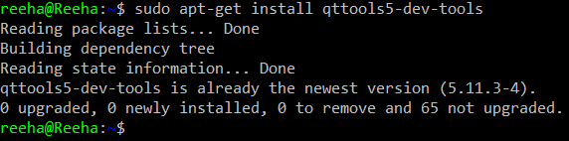

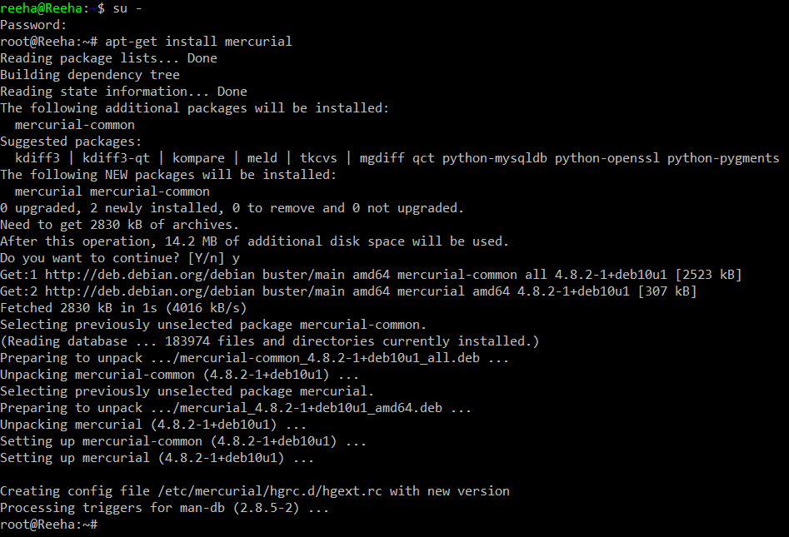

After you’re done installing, change directories to check if NetAnim program is initiating properly

$] cd ns-allinone-3.33

$] cd netanim-3.108

$] make clean

$] make

$] ./NetAnim

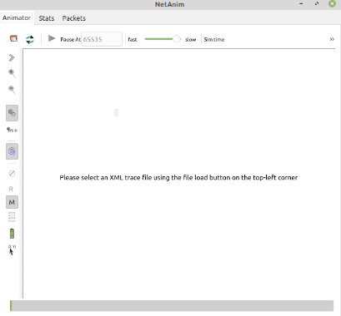

After successful initiation, we have to make some changes in our pre-existing .cc file so that it could be run successfully

* Ensure that your wscript includes the "netanim" module. Example as in: src/netanim/examples/wscript.
* Also include the header [#include "ns3/netanim-module.h"] in your test program.
* Add the statement "AnimationInterface anim ("animation.xml");" before Simulator::Run().

Finally you can run any ns3 .cc file after making the mentioned changes by the command

$] Enter the directory you’ve saved the file in

$] ./waf –run file_name

## **Output:**

